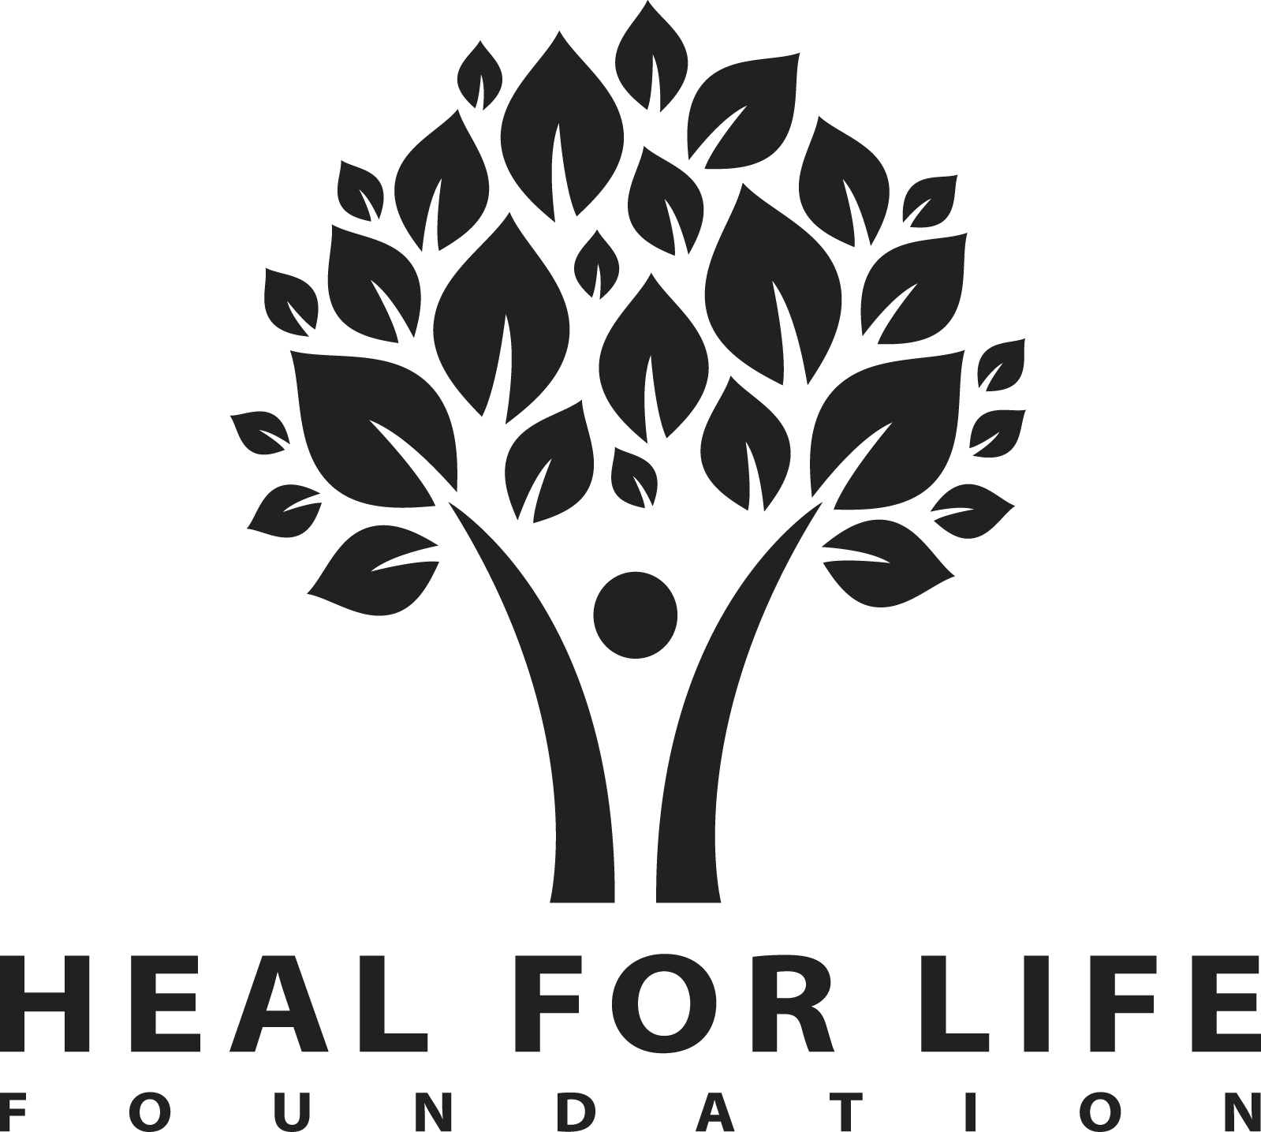

REGISTRATION FORM

Registration Form: It is important that this is filled in by the guest attending.

(THIS INFORMATION IS CONFIDENTIAL UNLESS DUTY OF CARE REQUIRES DISCLOSURE)

2024 Programme dates:
Sunday 27th July – Friday 1st August
Sunday 14th September – Friday 19th September
Dates of the Programme you wish to attend:

Please do not make any work or travel arrangements prior to receiving confirmation from us

First Name Surname M or F

Address

Town County Post code

Phone - Home Mobile Work

Email address

Your Age Any children? Y or N If yes what ages?

Current Employment (You can circle more than one)

Full Time Part Time / Casual Student
Retired On Benefits Other

Is this your first healing programme with Heal For Life? Y or N
If no, was your programme more than a year ago? Y or N

How did you find out about Heal For Life Foundation?
Organisation/service (name)

Family/Friends Web search Leaflet/ Brochure Seminar

How will you be arriving to attend your programme?

P Private transport Public transport: Station (The nearest station is Southminster)

Once you have been accepted onto the programme we will send you confirmation.

Who do you wish to nominate as your EMERGENCY CONTACT PERSON?
This person will be contacted if you need to leave before the end of the programme or in a health emergency. Please ensure that your contact person knows that you have given their details to us

Name Relationship to you

Phone - Home Phone - Mobile Phone - Work

Have you ever had a drug, alcohol, or other addiction? Y or N

If YES Alcohol Illicit Drugs Non-prescription medication Other

You need to be free of your addiction for at least a year before the healing week.

MEDICAL DETAILS
This information will be kept confidential and treated with respect for your privacy

Do you take any medication? Y or N If yes please list medications

Do you have any physical or mental conditions that we need to know about.
e.g. asthma, diabetes, high blood pressure, epilepsy, bipolar disorder, schizophrenia, DID, PTSD, anorexia, etc.

Do you have any allergies ? Y or N If yes please list

Do you have any phobias/fears that you feel it would be useful for us to know about?

To enable us to help you better you may wish to let us know the type of trauma you are a survivor of:

Physical Emotional Sexual Spiritual Neglect
SRA Poor Parenting Bullying Abandonment Incest
Domestic Violence Early Childhood Illness Divorce, Death of a parent/sibling

Other e.g. war, refugee, natural disasters, medical emergency

Do you have any particular dietary needs?

Has a member of your family done a healing week before? Y or N

Is there anything about your current circumstances that might be useful or helpful for us to know about?

Please note down what your goals might be for the week, eg what would you like to change about yourself or your life by attending the programme?

Key Safety Principles Please tick and sign below to indicate you have read, understood and agree

I agree to keep confidential anything I hear about other people during the programme
I agree not to bring illicit drugs or any alcohol to the programme
I understand that if I leave the property during the programme, for any reason, I cannot return
I am committed to my healing and will avoid distractions such as TVs, newspapers, radio, magazines, games, cards, novels, laptops and tablets
I understand that I will not be able to keep or use my mobile phone during the week
I understand that if I self-harm I may be asked to leave
I understand that if I behave in an unsafe manner to other guests I will be asked to leave

I agree to comply with the key safety principles above; I have read and understand all the information in relation to the healing programme.

Signature: Date:

Your healing programme will be confirmed once we have received your registration and deposit payment. PLEASE do not make any travel or work arrangements until you have had a letter or email confirmation from us.

--------------------------------------------------------------------------------------------------------------------------------------------

FEE INFORMATION

The following fee covers 5 nights’ accommodation, food and all workshops during the programme.

To secure a place we ask for a minimum £200 deposit (refundable up to six weeks before the start of the programme)
Programme Fee is £950
On each week we have a limited number of sponsored places available but we do require you to pay the deposit of £200 yourself, up to £750 can be made available from our Bursary Fund. However, as we have a limited number of sponsored places, we ask you to contribute as much as you are able to afford. If this would better fit your financial circumstances please contact the Office.
If you would like to pay by cheque or money order (payable to Heal For Life Foundation UK) please forward to:

Admin Office, Heal For Life UK, Cumberland Court, Church Street, Wye, TN25 5BJ. Please remember to put your contact details in the envelope if you are sending a cheque separately to your registration form

We can receive payments by Electronic Credit Transfer (BACS), please ask the Office for details

We do not currently have facilities for payment by Credit/Debit card.

